Progress report

Url: [https://buylocksmithdeals.com](https://buylocksmithdeals.com/)

1. Vendor login page   
   <https://buylocksmithdeals.com/wp-admin>  
   userid: vendor

password: 123456

1. Vendor registration page is done. You can see the page after disable the Under construction plugin. Please refer the image below.

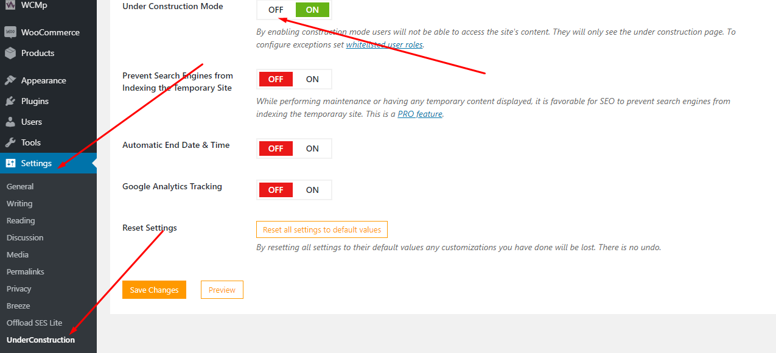

Vendor register page url is as below.  
[https://buylocksmithdeals.com/vendor](https://buylocksmithdeals.com/vendor-registration)

1. Created section where all product are listed and site admin can assign products to the vendors. Please see image below.  
   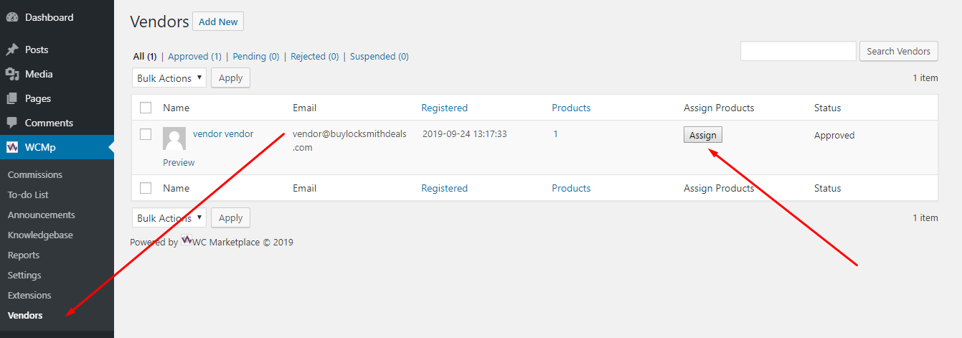

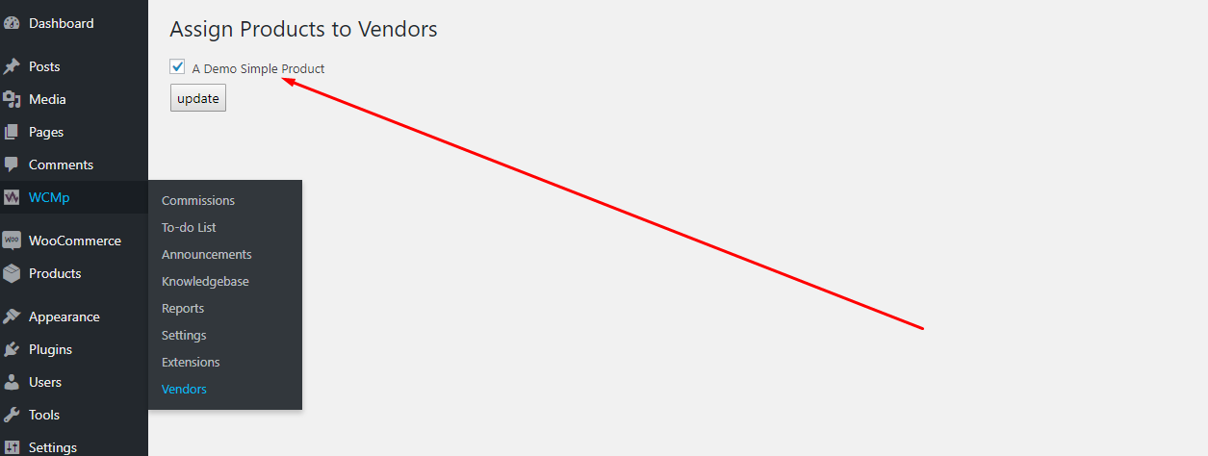

1. Vendor product list in vendor admin.  
   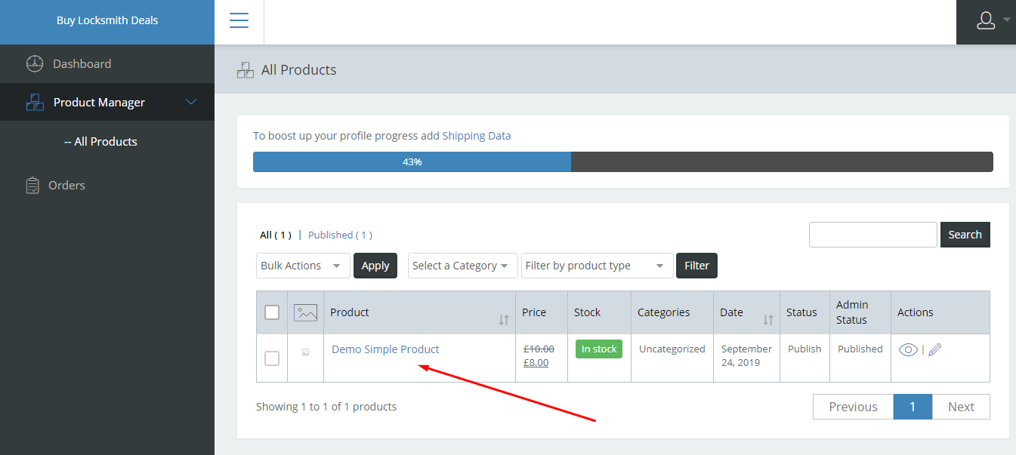
2. Edit Product page to change the product price. Please see images below.  
     
     
   